Chapter 13 Exploring the final frontier
Short investigation 13.1: Measuring g
Name:
Aim
To determine the rate of acceleration due to gravity using the motion of a pendulum
Materials
Retort stand, boss head and clamp, approximately 1 m of string, 50 g mass carrier or pendulum bob, stopwatch, metre rule
Theory
When a simple pendulum swings with a small angle, the mass on the end performs a good approximation of the back-and-forth motion called ‘simple harmonic motion’. The period of the pendulum, that is the time taken to complete a single full back-and-forth swing, depends upon just two variables: the length of the string and the rate of acceleration due to gravity. The formula for the period is $T=2π\sqrt{\frac{l}{g}}$ where T is the period of the pendulum (s), l is the length of the pendulum (m) and g is the rate of acceleration due to gravity (m s^{–2}).
Method
- Set up the retort stand and clamp on the edge of a desk as shown in the figure below. Tie on the string and adjust its length to about 90 cm before attaching the 50 g mass carrier or pendulum bob to its end.
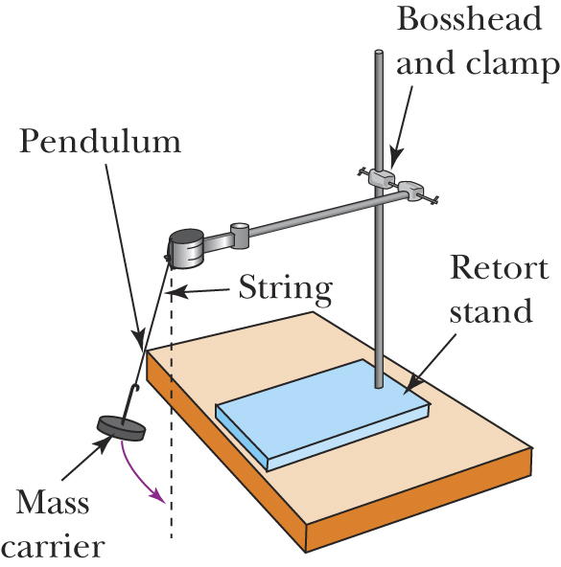

- Using the metre rule, carefully measure the length of the pendulum from the knot at its top to the base of the mass carrier. Enter this length in table 13.1A.
- Set the pendulum swinging gently (30° maximum deviation from vertical) and use the stopwatch to time 10 complete back-and-forth swings. Be sure to start and stop the stopwatch at an extreme of the motion rather than somewhere in the middle. Enter your time for 10 swings in table 13.1A.
- Repeat steps 2 and 3 at least five times, after shortening the string by 5 cm each time.
Results
Table 13.1A
Trial | Time for 10 oscillations  (s) | Period,  T (s) | Period squared,  T² (s²) | Length of pendulum,  l (m)
1
2
3
4
5

Analysing the results
- On the grid provided, draw a graph of period squared versus length of the pendulum. Plot T² on the vertical axis and l on the horizontal axis.

- Your graph should display a straight-line relationship. Draw a line of best fit and evaluate the gradient.
- Rearrange the pendulum equation given earlier to the form$T^{2}=kl$ where k is a combination of constants.
- Compare this formula with the general equation for a straight line: $y=kx$. This comparison shows that if T² forms the y-axis and length l forms the x-axis, then the expression you derived for k in step 2 should correspond to the gradient of the graph you have drawn.
- Complete this expression: gradient =
Use your expression to calculate a value for g, the acceleration due to gravity.
- This method usually produces very accurate results. Can you suggest a reason why it should be so reliable?
- What are the sources of error in this investigation?
- What could you do to improve the method of this investigation to make it even more accurate?
Conclusion
Write an appropriate conclusion that responds to the stated aim of this investigation.
Notes:

